1. Task 1: 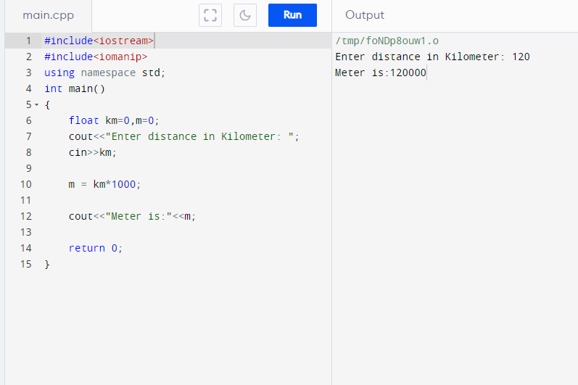
2. Task 2: Graphical user interface, text, application

   Description automatically generated